Dwight Morrow A@E
AP Statistics
2019 Summer Assignment

Ms.McClelland
dmcclelland@epsd.org

Welcome to AP Statistics! This course is not your typical math course. This is the one math class you are guaranteed to use throughout your life. To be successful in this course you need to be competent in basic algebra, but more importantly, you must be able to read and write, and to explain your answers, not just simply get the correct answer.

Although this is a math course, AP Statistics concentrates much more heavily on thinking, reasoning, writing, and communicating than it does on number-crunching. Graphing calculators and computer software programs will do most of the math for you.

This course is focused on four interrelated areas of concentration;
Sampling and Experimenting. What plan would you implement to conduct a study? What is simulation and how can we use it to model real-life phenomena?
- Exploring Data. What patterns do we see in a set of data? What do these tell us about the data? What can we learn from them?
- Anticipating Patterns. What can you surmise about random phenomena by using probability? How can you extrapolate your model into the future? What might you hope to have happen?
- Statistical Inference. What conclusions can we make about an entire population based on a relatively small sample? How valid are these conclusions?

This summer assignment is meant to introduce you to statistics. Recognizing that summer should also be a time for you to relax, have some fun and recharge your batteries, this assignment is not meant to be too time-consuming or intense. Have fun with it – explore and try to learn something about the amazing world of stats.

A. Buy a TI-84 Calculator or Get an App:

You MUST have a graphing calculator for use at home. Without it, you will be unable to complete the homework. All of the examples and problems we will work on will be based on this calculator. You will be using your calculator almost every class period and familiarity with it is required for success on the AP Exam. You will probably need this calculator for future math classes and for college. If not, you can sell it when the year is over.

At the very least, download one of the following apps for your phone:
- Apple IOS: GrafNCalc 83 (costs about $6)
- Android: wabbitemu - free
These emulate the TI-84 calculator, and are a good substitute.
OR on your computer, download a free sample of the TI-84 software (see Texas Instruments downloads). You can use this for 3 months.

We do have a class set of calculators for use in school, but this is NOT a substitute for having your own. You will be REQUIRED to have one of the above. I will be checking to see that you have one of the above by the end of the first week of school.

Graded Summer Work: NOTE: THIS SHOULD BE YOUR OWN WORK. THE PROBABILITY THAT 2 OR MORE OF YOU WOULD CHOOSE THE SAME MATERIAL IS CLOSE TO ZERO. DO NOT COPY SOMEONE ELSE’S WORK, OR BOTH OF YOU WILL GET NO CREDIT. ALL WORK WILL BE DUE BY THE END OF THE SECOND WEEK OF SCHOOL,

Watch Hans Robling

Watch 2 or 3 videos by Hans Rosling. (Just google him and you’ll see all sorts of stuff. He has several TED videos, most are not that long, and many videos on YouTube.)
Go to schoology (access code: : VCMN-37Q6-M472V) and join the discussion about his videos. What are you learning, what surprises you, what do you want to learn more about? Anything that comes to your mind. Say something that means something to you, not just something to satisfy this requirement. Respond to each other. Be sure to name the video that you watched and where you found it. Have fun, there is fascinating material out there.
Your requirement is to make at least one meaningful original post, and respond to at least 2 of your classmate with your own thoughts. Dig deep!! This will be graded as follows: B for just meeting the requirement, A- to A for showing insight, originality of thought, curiosity, etc. (You don’t have to write a lot, just make it meaningful.)

- Begin learning the material for Chapter 1 by signing up for Khan Academy. The link to sign up for the course can be found on Schoology (class code: VCMN-37Q6-M472V) Complete the first unit, Analyzing categorical data, including the quizzes and tests. We will be reviewing this material during the first week of class, so if you can do it before school starts that is best. This will also be graded.

You will find that in AP Statistics, there will be A LOT of reading involved. Every problem we do is a word problem. Your final answer to most problems will be a written answer, not just a number. The actual math we do in class is fairly easy, and a graphing calculator will do most of the work for us. So what’s so tough about this class then if the math is so easy, you ask? The actual concepts learned in class, memorizing some formulas and conditions, and being able to work out a problem with the correct procedure is the tough part. Instead of working out math problems this summer that you won’t even do in statistics class, I want you to focus on noticing statistics around you – in what you read, see online or on TV, hear about on the radio, etc.

This class is to prepare you to take the AP Statistics exam so you may receive college credit. Chances are, no matter what major you pick in college, you will have to take some sort of statistics class. You should take AP Statistics very seriously, study hard throughout the year, take the AP exam in May, and, hopefully, receive a high enough score to place out of it in college. By signing up for this course, you are agreeing to pay for and take the AP exam in May of next year.

By the way, did you notice my annoying font? I just listened to a podcast about jump-starting creativity. One proposal suggested that using a font that is difficult to read will result in better comprehension. Weird, right? Remind me to tell you about it in September, and ask you what you think.
D. Sign up for texting at Remind.com

Use this to communicate with me whenever you need to. I’ll try to respond as quickly as possible, though I will be away off and on during the summer and might not be checking email or texts.

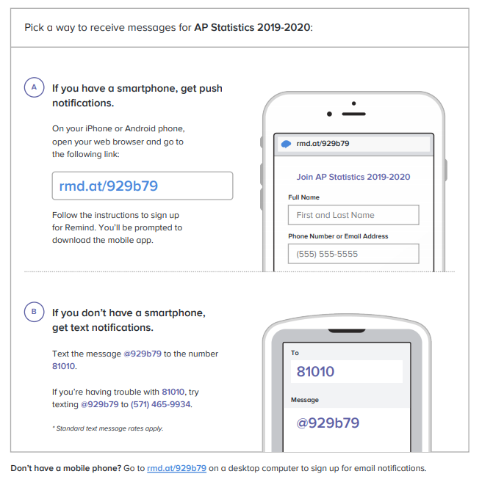

It is expected that all students sign up to receive these messages, unless you can provide a reason why you cannot!

Questions???

Email me at dmcclelland@epsd.org, or text me.
Have a great summer and see you in September.

